

**S. B. JAIN INSTITUTE OF TECHNOLOGY,**

**MANAGEMENT & RESEARCH, NAGPUR.**

# Activity No 2

**Aim: Virtual Lab:** Understand the use of table tags and its use in HTML code and perform the following tasks:

1. Explain the working of ‹table› tag in html.
2. Make use of ‹table› tag to insert table having Five rows and Three columns.
3. Design a web page containing a table for showing name and hours of virtual lab used by any 10 students using ‹table› tag of HTML.

**Name of Student: Ashwini Anil Malvi.**

**Roll No: CS23051**

**Semester/Year: II / I**

**Academic Session:** 2023-24

**Date of Performance**: /02/2024

**Date of Submission**: /02/2024

**AIM:** **Virtual Lab:** Understand the use of table tags and its use in HTML code and perform the following tasks:

1.Explain the working of ‹table› tag in html.

2.Make use of ‹table› tag to insert table having Five rows and Three columns.

3.Design a web page containing a table for showing name and hours of virtual lab used by any 10 students using ‹table› tag of HTML.

**OBJECTIVE/EXPECTED LEARNING OUTCOME:**

* To apply the knowledge of basic HTML tags.
* To apply the knowledge of attribute tags.
* Able to design the Invitation Letter.

**HARDWARE AND SOFTWARE REQUIRMENTS:**

**Hardware Requirement:**

* + Processor: Minimum 1 GHz; Recommended 2GHz or more
  + Ethernet connection (LAN) OR a wireless adapter (Wi-Fi)
  + Hard Drive: Minimum 32 GB; Recommended 64 GB or more
  + Memory (RAM): Minimum 1 GB; Recommended 4 GB or above **Software Requirement:**
  + Sublime text 3
  + Google Chrome
  + Notepad ++
  + Notepad
  + Visual Studio Code

**THEORY:**

**Table Tag**

* The HTML tables allow web authors to arrange data like text, images, links, other tables, etc. into rows and columns of cells.
* The HTML tables are created using the &<table> tag in which the &<tr>tag is used to create table rows and <td>tag is used to create data cells. The elements under &<td> are regular and left aligned by default. **Table Cells**

Each table cell is defined by a <td> and a </td> tag.

**Table Rows**

Each table row starts with a <tr> and ends with a </tr> tag.

**Table Headers**

Sometimes you want your cells to be table header cells. In those cases use the <th> tag instead of the <td> tag

**Rowspan:** It is used to merge the rows of table

**Colspan:** It is used to merge the columns.

**Cellspacing:** Cellspacing Attribute is used to specify the space between the cells.

The cellspacing attribute is set in terms of pixels.

**Cellpadding:** The cell padding attribute places spacing around data within each cell.

The cell spacing attribute places space around each cell in the table.

**CODE:**

<html>

<head>

<title>table</title>

</head>

<body>

<table border="2">

<tr>

<th>

Name

</th>

<th>NO. of Hours</th>

</tr>

<tr>

<th>Shyam</th>

<th>2</th>

</tr>

<tr>

<th>Rohit</th>

<th>2.5</th>

</tr>

<tr>

<th>Ram</th>

<th>1</th>

</tr>

<tr>

<th>Seeta</th>

<th>3</th>

</tr>

<tr>

<th>Geeta</th>

<th>1.5</th>

</tr>

</table>

</body>

</html> **OUTPUT/SCREENSHOTS:** 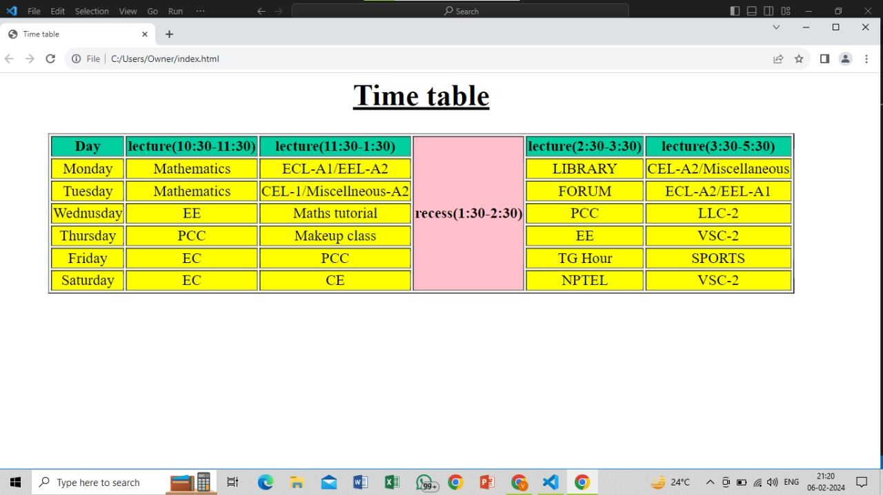

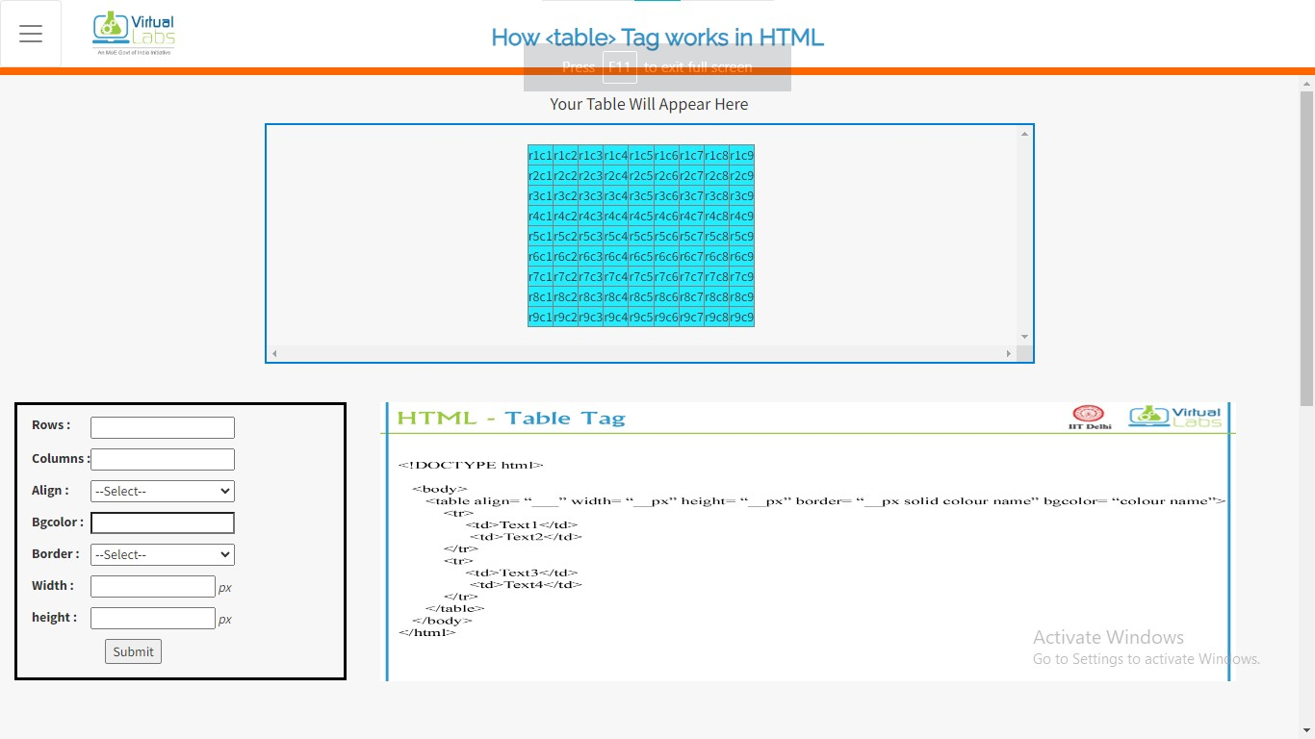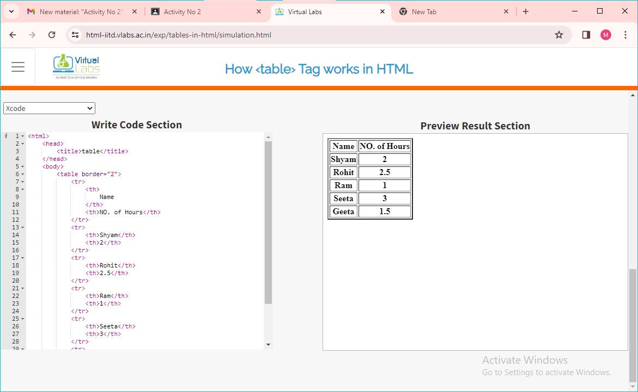

**CONCLUSION:**

We successfully understand the use of table tag(<table>) in html and learned to use virtual lab.

**DISCUSSION QUESTIONS:**

Q.1) What is the use of table?

Q.2) How do you use cellpadding and cellspacing?

Q.3) Which tag is used for heading in table?

Q.4) Which tag is used to add columns in the tables?

Q.5) <td> tag, td stands for?

**REFERENCE:**

* [*https://www.w3schools.com/TAgs/default.asp*](https://www.w3schools.com/TAgs/default.asp)
* [*https://simplycoding.in/html-tables-question-bank/*](https://simplycoding.in/html-tables-question-bank/)
* [*https://www.tutorialspoint.com/html/html_lists.html*](https://www.tutorialspoint.com/html/html_lists.html)
* [*https://www.tutorialspoint.com/html/html_tables.htm*](https://www.tutorialspoint.com/html/html_tables.htm)